Setting which fields are displayed when searching
This also sets which fields are shown when performing a bulk operation
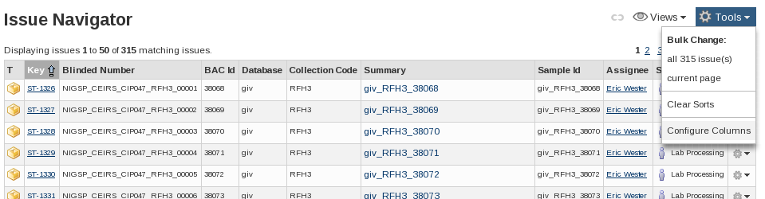
Issue Navigator: Tools drop-down
In the Issue Navigator:
Select the 'Tools' drop-down menu, situated on the right above the list of issues.
Select Configure Columns at the bottom of the menu
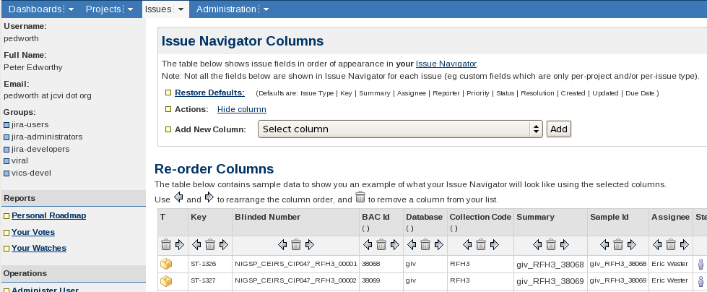
Issue Navigator Columns
This screen allows columns to be added, removed and arranged.
Adding/re-adding fields is carried out one field at a time. Select the field to add from the 'Select Column' drop-down menu and then click 'Add'.
The menu contains all of the fields in JIRA and so can be quite long. The fields are in alphabetical order and so looking up the exact name of the field (as found on the Sample/Sub-Task's summary view) can save time.
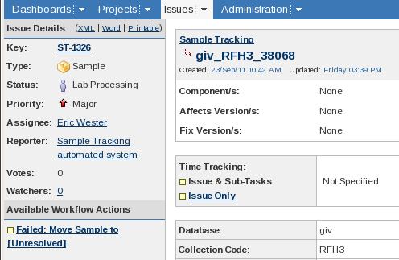
In the above screen shot the field names are 'Database' and 'Collection Code'
The rest of the operations are done using icons that are in the example table directly under the column titles. The icons are:
Swap the column with the column to its left or right
Remove the column. If a column is accidentally removed it can be re-added via the Add new
Column drop-down.

Missing Columns
Issue Type specific fields are not shown in the Issue Navigator unless that Issue Type has been explicitly selected. e.g. For the Collection Code to be visible 'Sample' must be among the Issue Types selected. Explicitly setting the issue type is needed even if the search only matches Issues of one Issue Type.

Filters: Column Layout
The above procedure sets and modifies a user's default column settings. If a search is saved in the Issue Navigator it can then have its own column layout associated.
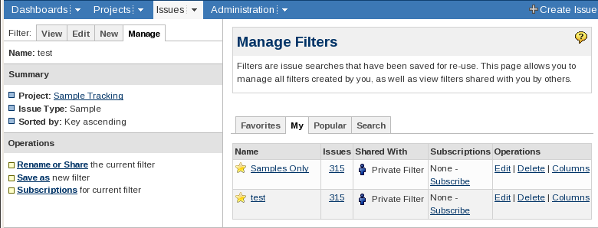
The 'Columns' link under Operations opens the same 'Issue Navigator Columns' page.

